Weekly Report Out 5

Team: Drone Link

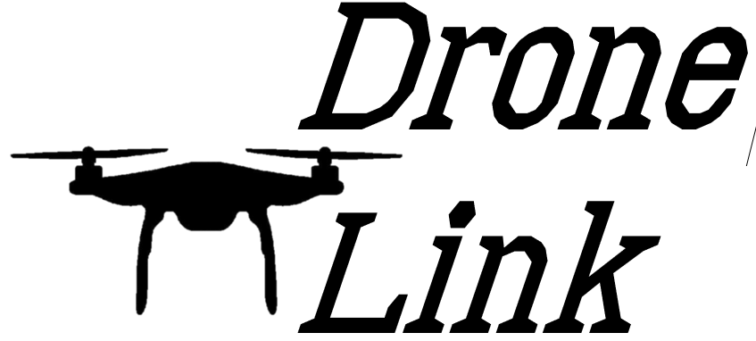Sam Forest, Alex Holt, Vincent Krenz, Lucas Larocco, Blake Masbruch

10/16/2020

Senior Design Adviser: Professor Wiedenhoeft

ScrumMaster: Vincent Krenz

Current Cadence: 2

**Progress**

The goal of this cadence was to setup our working environment and making sure all portions of our original choices in frameworks. We have achieved the basic setup and are looking forward to jumping into some more tangible gains on our project. After seeing the drones, we are more excited for the project and have bonded more as a team and look forward to flying some of the smaller, easier to handle, drones to have a hands-on experience. The headsets were even more informative with the two types of receivers and watching them receive data in real time especially since its receiving and relaying information is a basic version of our overall project.

**Future Progress**

Grooming of the backlog will set us up for a successful Cadence 3 and allow us to get into development. As this happens, we will be fully utilizing our roles DevOps, ScrumMaster, PO, and Notetaker as their responsibilities grow with full development Cadences. We also will be relying less on Alex to be PO/knowledge base and using him as a final decider as PO.

**Reflection**

This Cadence was a lot about setup and learning. This resulted in us waiting on each other a little bit as we created environments. We now can move into a development frenzy and allow us to make real development progress. We also looked to make process improvements such as report out templates and streamlining our retrospective process.